LINUX PROCESS MANAGEMENT

1. List out highest priority process in the system

**COMMANDS USED:-**

root@ip-172-31-30-52:/home/ubuntu# ps -elf | grep -e'-20'

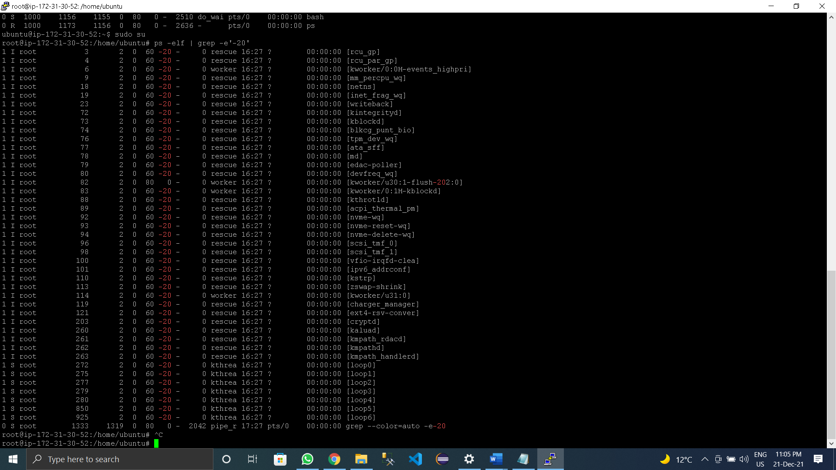

2) Open terminal with 2 tabs or sessions  
    a)  run command "vmstat 1"  
    b) switch to another tab,  pause  running vmstat command for few seconds and resume it again

**COMMANDS USED:-** 1st Terminal

vmstat 1

2nd Terminal :-

root@ip-172-31-30-52:/home/ubuntu# kill -Stop 13061

root@ip-172-31-30-52:/home/ubuntu# kill -cont 13061

root@ip-172-31-30-52:/home/ubuntu# kill -Stop 13061

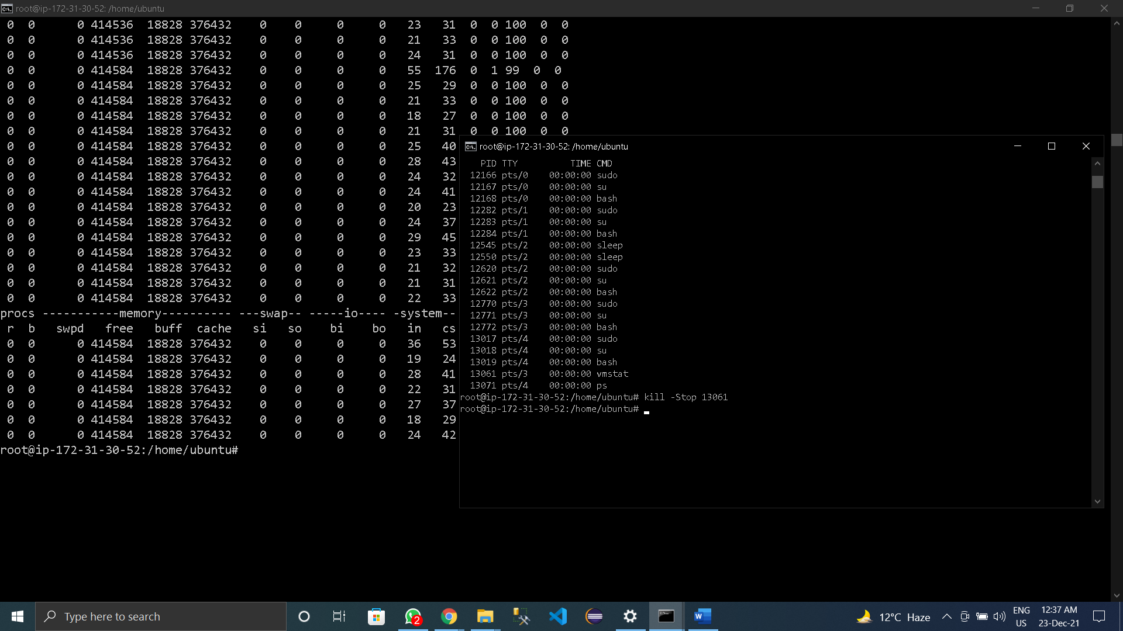

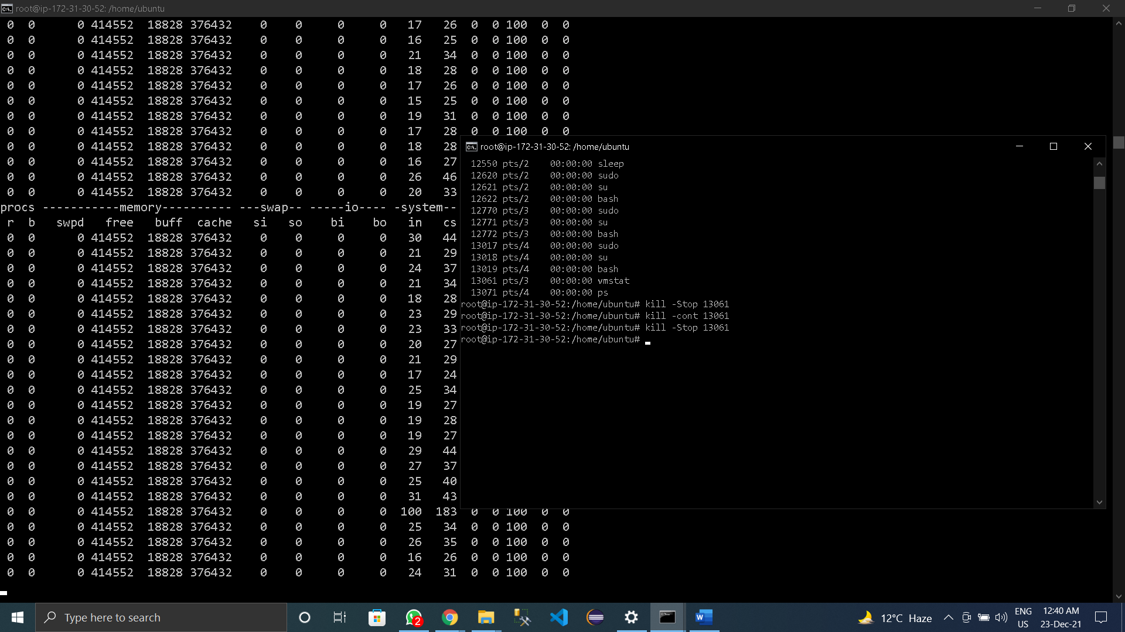

3)Find the process which is sleeping in "wait" state.

**COMMANDS USED:-**

**root@ip-172-31-30-52:/home/ubuntu# ps -elf | awk '$2=="I"'**

